**COMP 3069 Coursework 1 report**

**Li Kai WU 20027091**

**Part 1 (30%):**

1. Translate the vector to be incident the origin point

Change the point into incident the origin

=

1. Rotate 33 around X-axis to bring it to XoY plane
2. Clockwise rotate 60 about Z is equivalent to rotation about U
3. Clockwise rotate about Y to align it with Z axis
4. Undo rotations about X and Y
5. Undo the beginning matrix

**Specify the sub-matrix as M**

=

**Part 2 (70%):**

1. Snowman: In this part I’m going to make a snowman and let it revolves and on its own axis by clockwise in ten second for each round.
   * 1. GULT.framework, OpenGL.framework and libGLEW.2.2.0.dylib are used for this part.
     2. The Snowman, Animation, DisplayObject head file were built for make these clearer differentiate.
     3. The DisplayObject and MyScene are using for showing the animation on the screen, and this storing the snowman. These include some position, size and rotation function. Therefore, use <map> to save the snowman and call the snowman.
     4. The Animation class is storing the position and the location when moving the snowman by using runTime and set different position.
     5. And the main part of snowman, are the Snowman.h and Snowman.cpp. In Snowman.h make the class of Snowman, and each data that will be in the animation. In Snowman.cpp, the animation part is also existed, about the angle need to rotate, the time for each round (In here is ten second), draw the snowman step by step.

⬆︎ This is for the first snowball of snowman

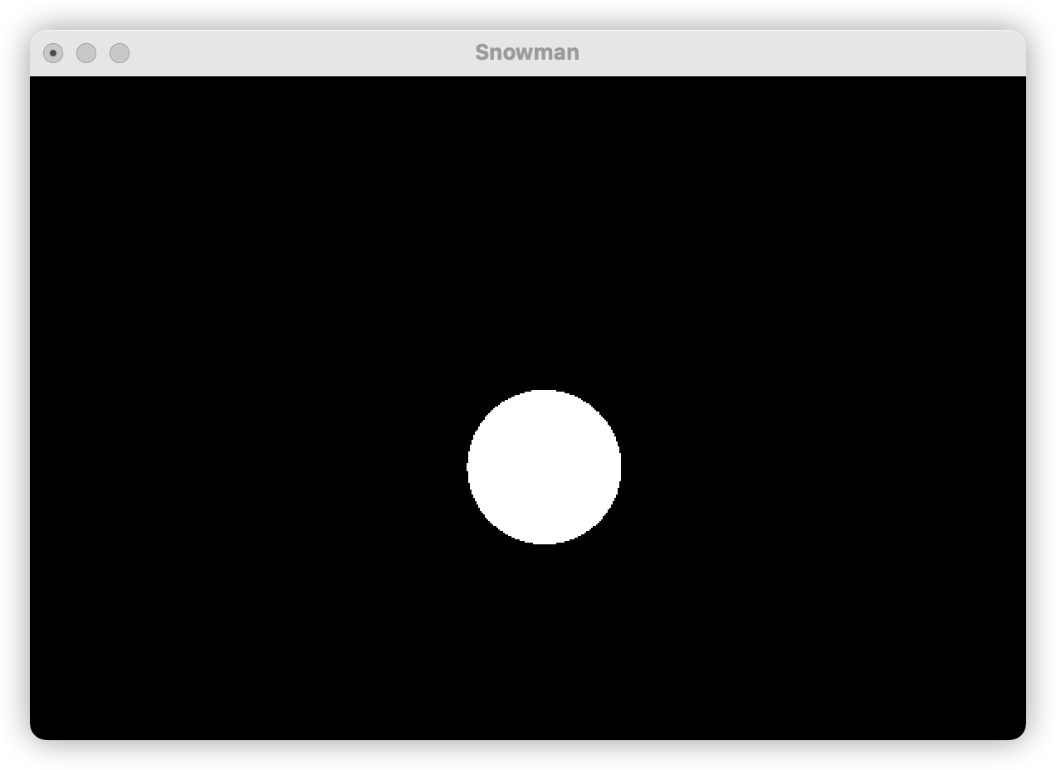

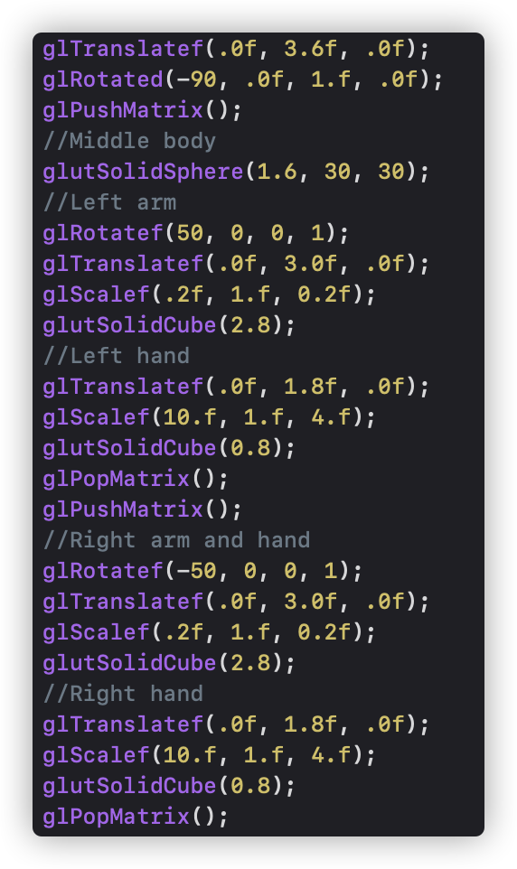 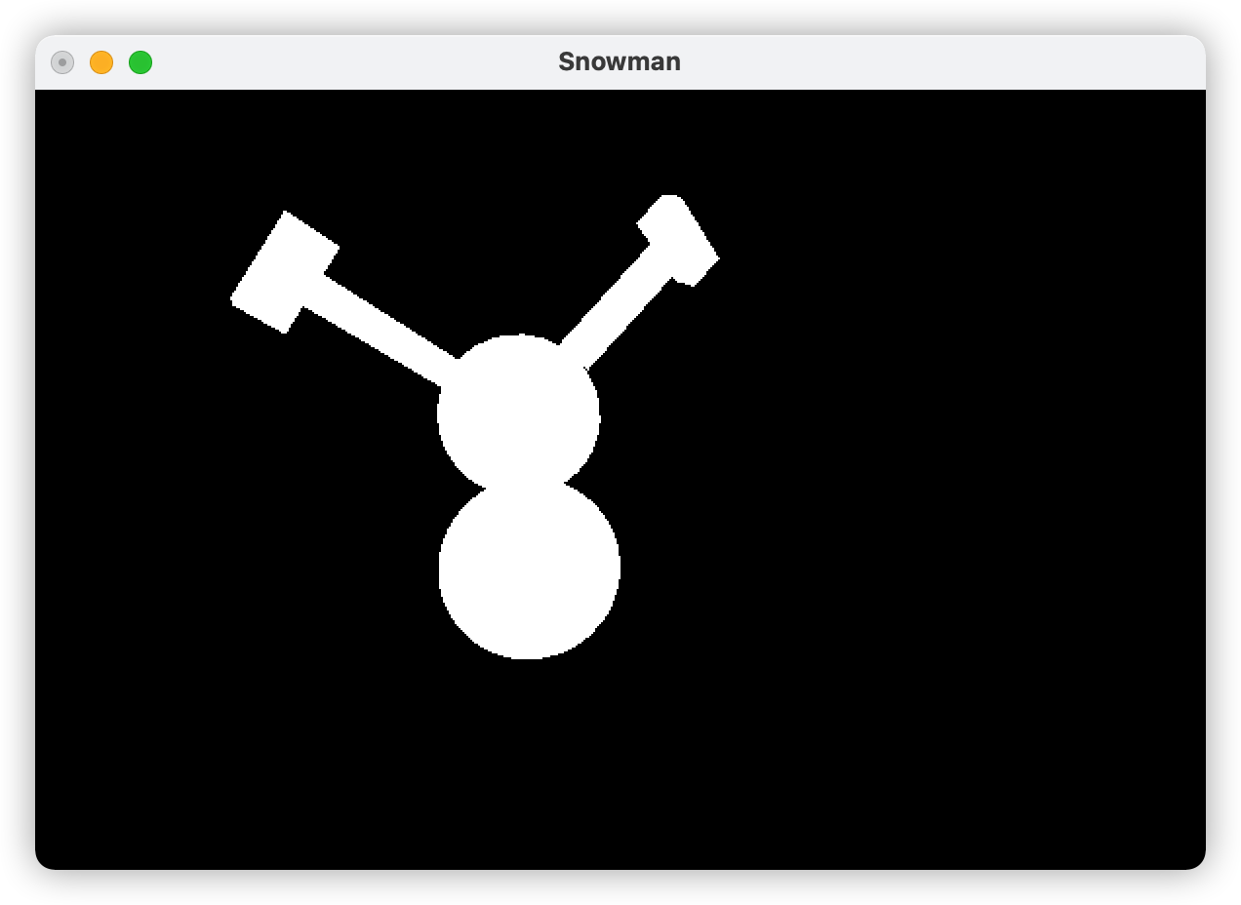

⬆︎ Second snowball, and with the arms, hands

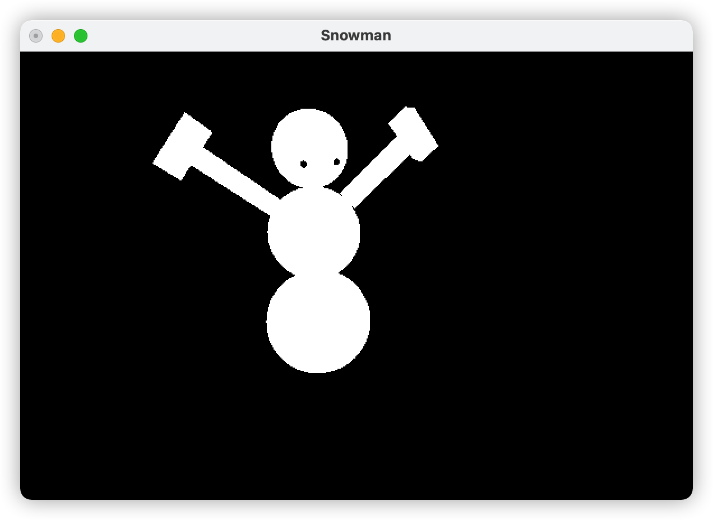

⬆︎ Third snowball which is head, and eyes.

⬆︎ In here must use float size, otherwise the size change will be too stiffness, and once size change in if function, we need to use glScalef to change the size of snowman.

1. Carousel: This part is based on the snowman, only need to change the object and the time of each round (Which is 7 second).
   * 1. Move the Animation, DisplayObject, and MyScene in this Xcode. And build the cpp and h file for carousel.
     2. In Carousel.h and Carousel.cpp build the carousel object.

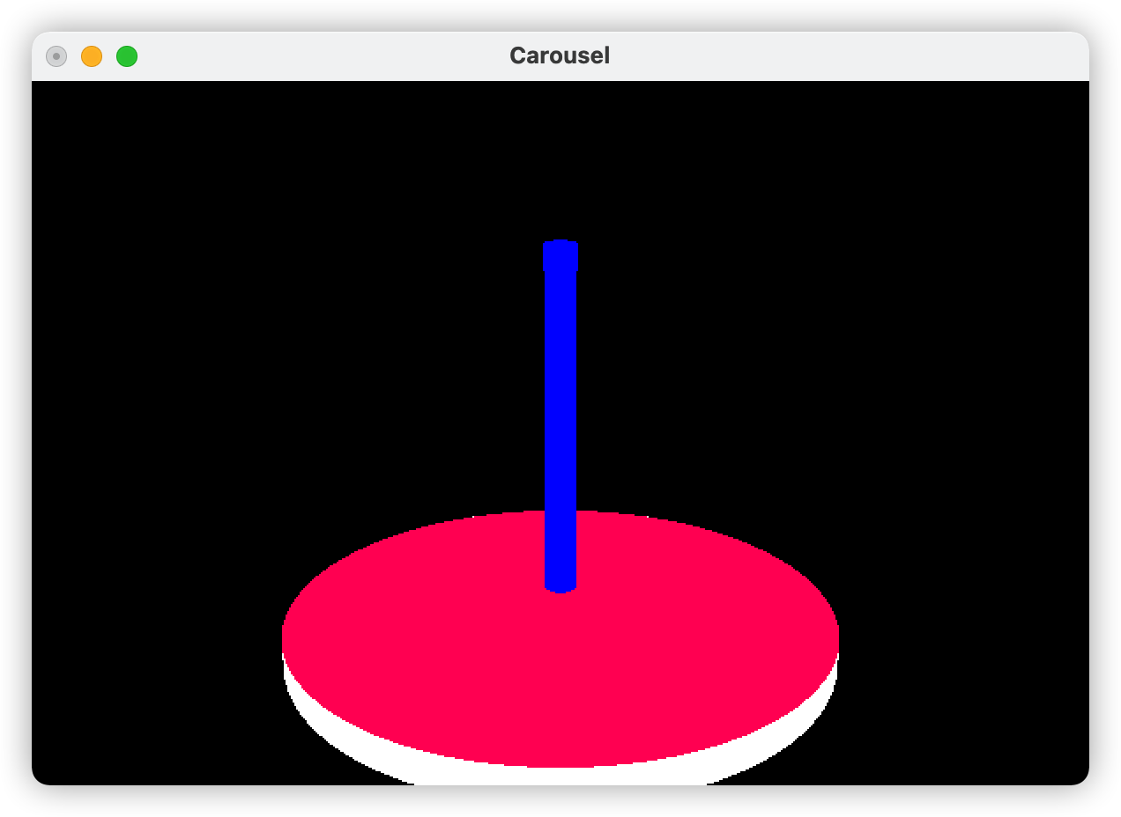

⬆︎ In here only draw the foundation of carousel. And use function called DrawCircleArea to draw colour and fill the top and the bottom of cylinder.

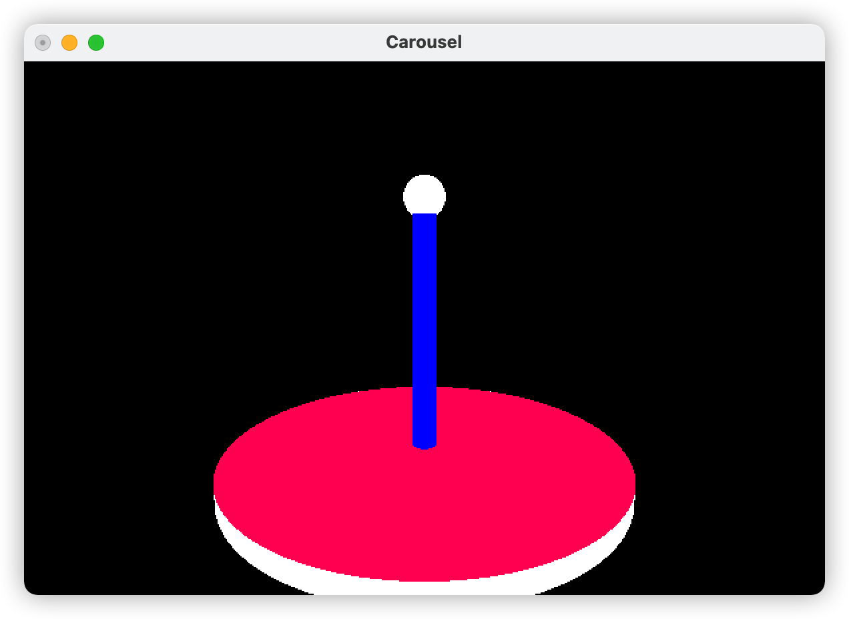

⬆︎ In here draw the ball on the top of foundation

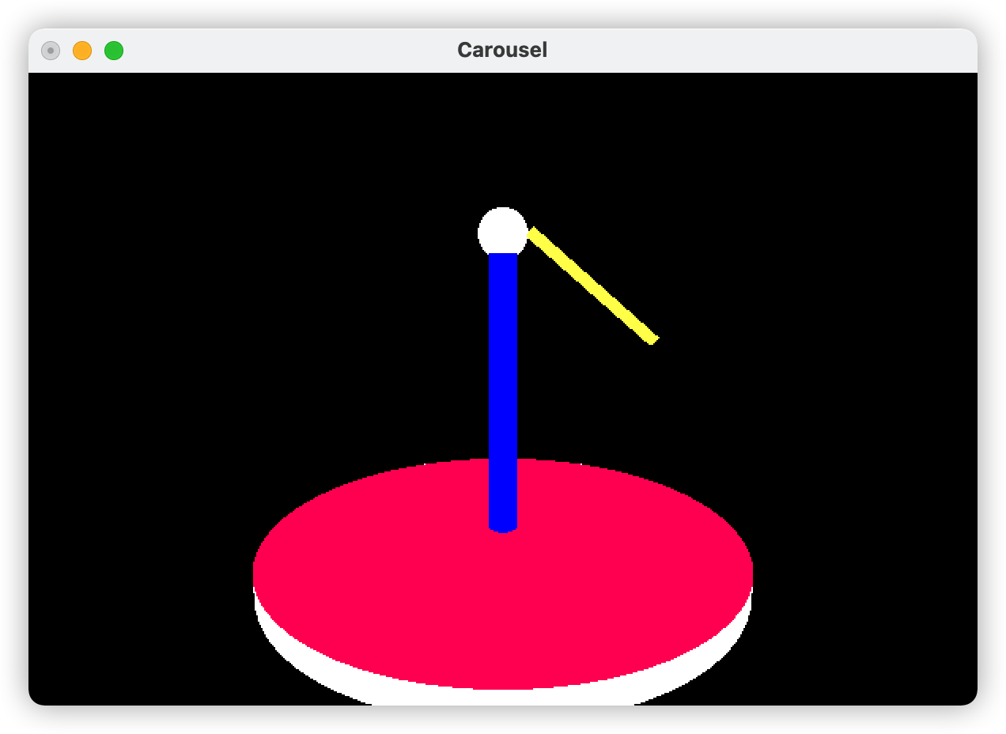

⬆︎ First line of rod

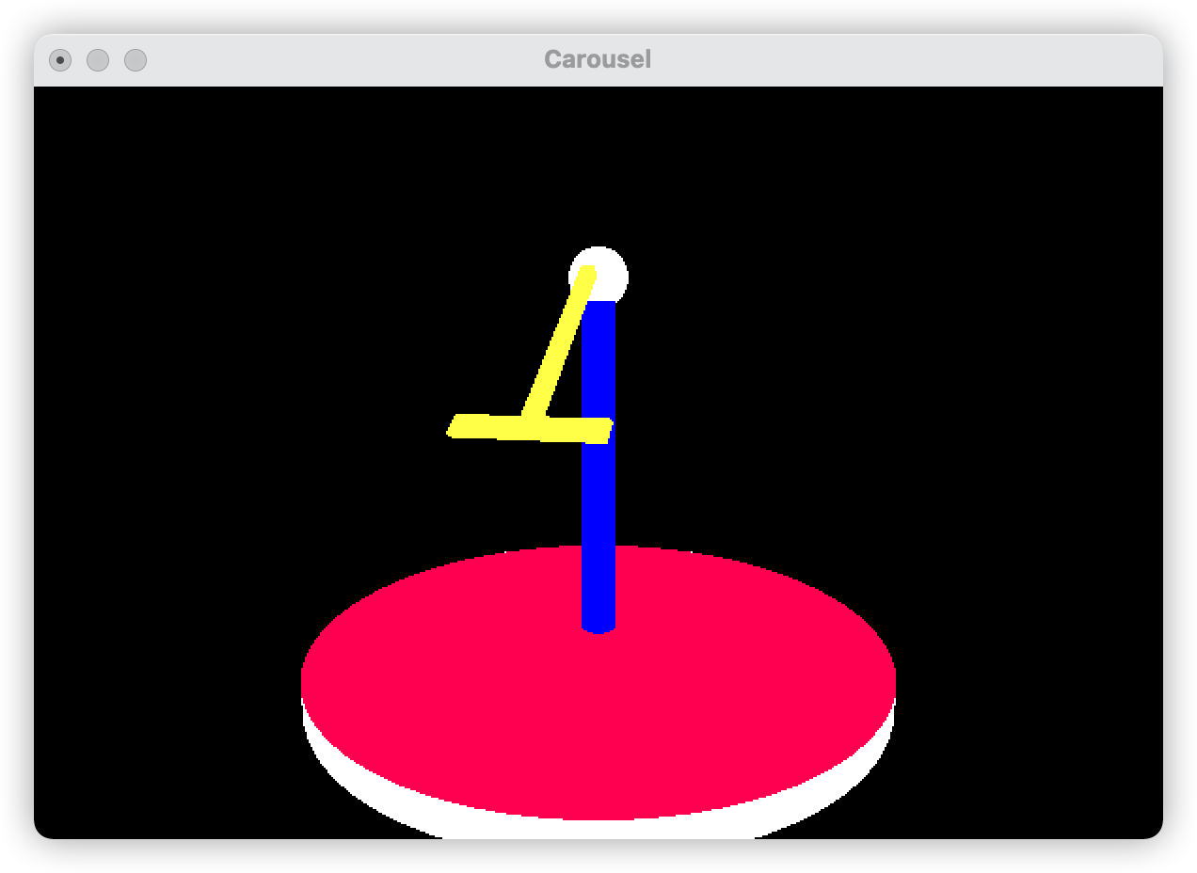

⬆︎ Following the rotate and translate to build second

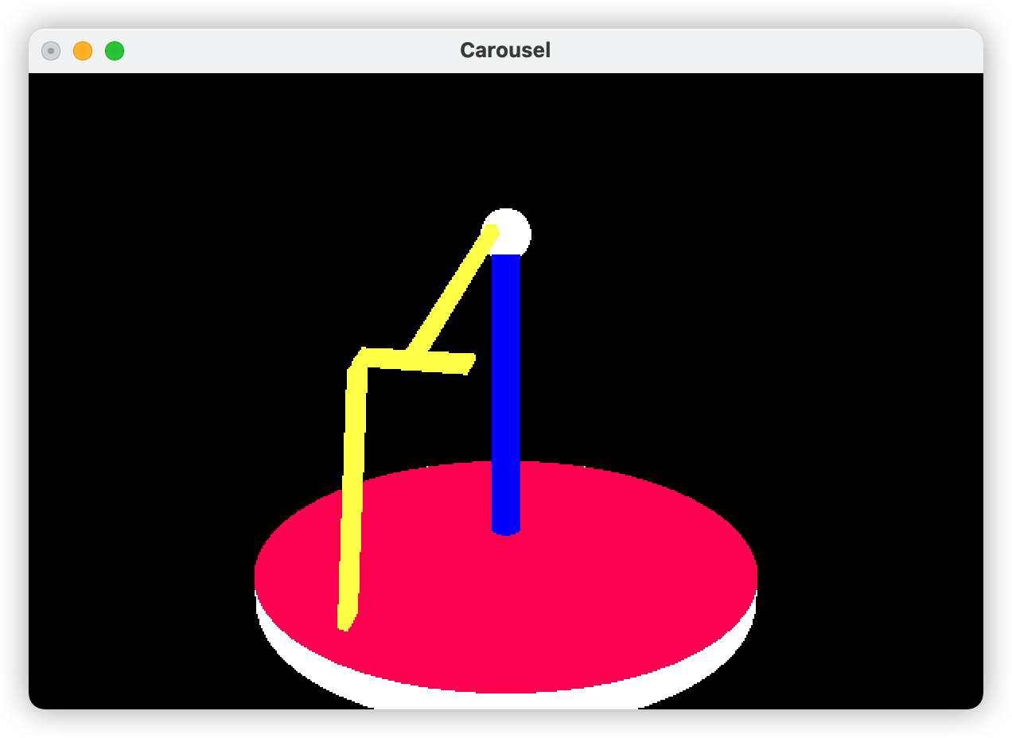

⬆︎ Still same as second line and change the length of third.

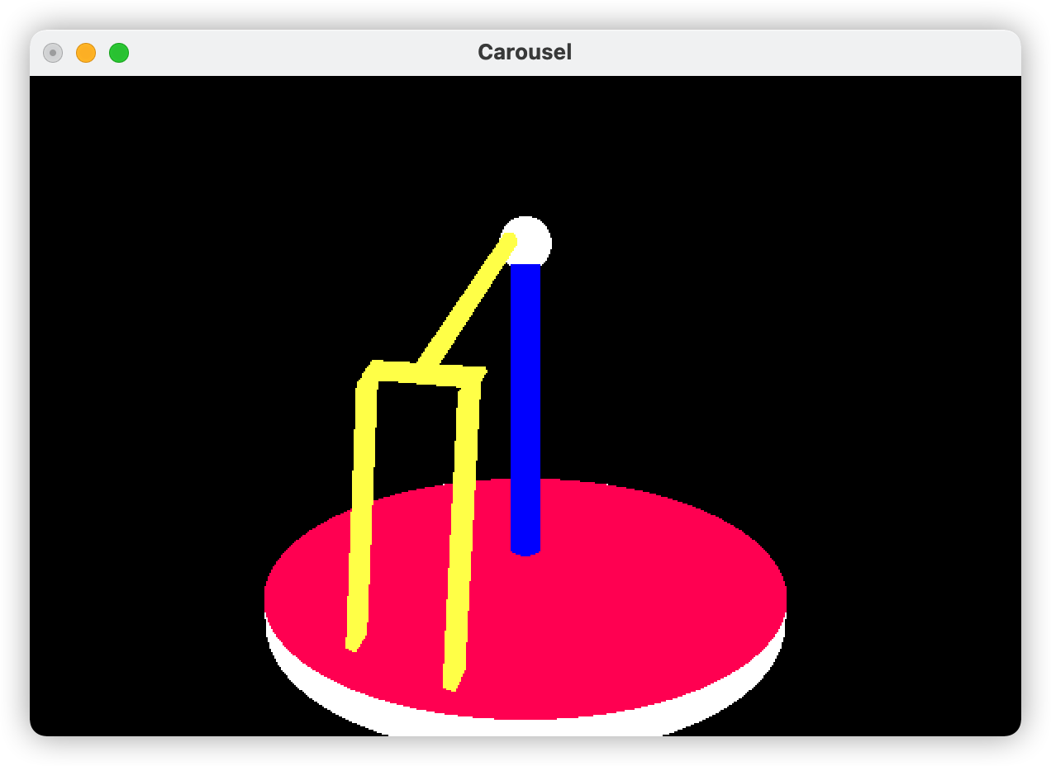

⬆︎ Copy third line and move a bit right to finish fourth line and finish the rod

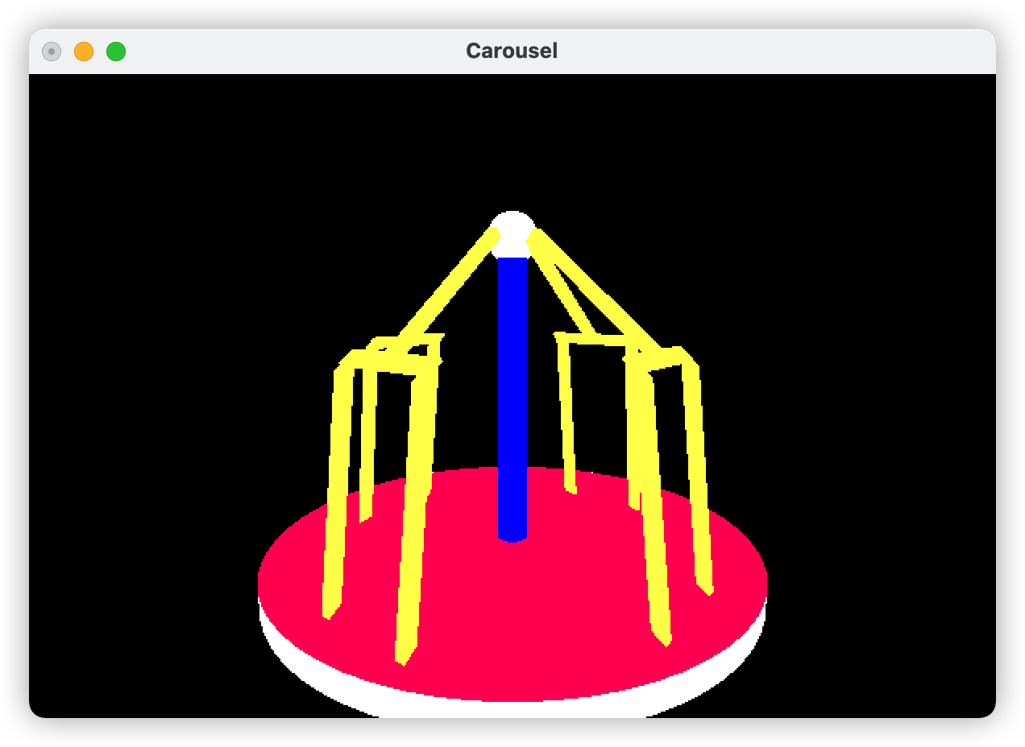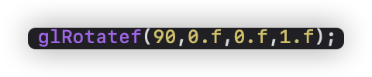

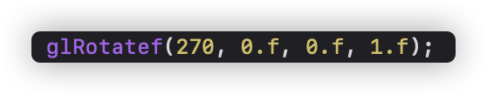

⬆︎ Copy four of them but change the angle of each object with 360 but divide by 4 which is 90, 180 and 270.

* + 1. Moreover, because carousel only need to rotation, so the function that can change size has been deleted.